Institute of Computer Technology

B. Tech Computer Science and Engineering

Subject: Basics Of Communication Systems (2CSE202)

**PRACTICAL-2**

**AIM: - Networking Commands**

**1. What are networking commands?**

• The **commands** (such as tracert, traceroute, ping, arp, netstat, nbstat, NetBIOS, ipconfig, winipcfg and nslookup) and their arguments, options and parameters used to troubleshoot the computer **network**.

**2. Why we require networking commands?**

• For trouble shooting and reassuring network activity

**3. Where to perform those commands?**

• On compiler for windows cmd and for linux, ubantu or cent-os terminal

**Below is CMD in Windows**

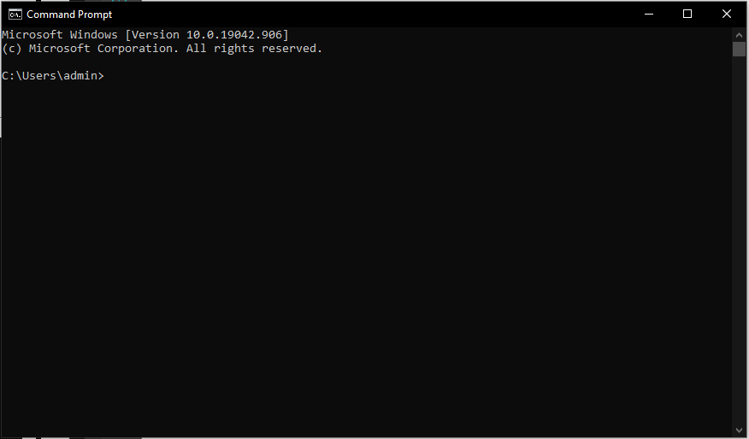

**Below is CMD in Linux - CentOS**

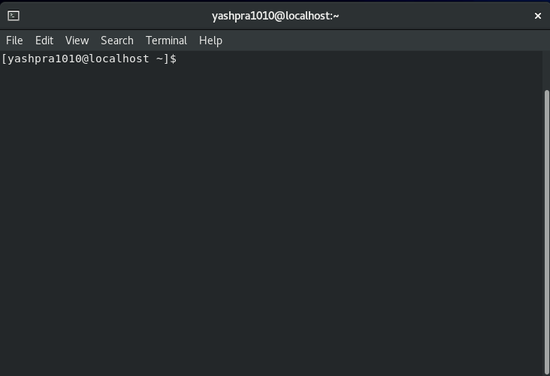

**4. What is default gateway and subnet mask?**

• Default Gateway is IP of your Router. In simple words, 192.168.0.1 and Subnet mask will be automatically deduced by operating system. 255.255.255.0.

**5. Why we need default gateway?**

• A default gateway makes it possible for devices in one network to communicate with devices in another network. If a computer, for example, requests a web page, the request goes through the default gateway before exiting the local network to reach the internet. Think of a default gateway as an intermediate device between the local network and the internet. The default gateway transfers internal data to the internet and back again.

**6. Types of default gateways**

**•** Broadband-Routers

• Dial-up

• Network-adaptors

**SCENARIOS AND LIST OF COMMANDS**

**CASE 1:**

Consider a situation, where you need to set a default gateway then how you will find your default gateway ip address?

For windows: ipconfig

For linux : netstat and iproute

CMD OUTPUT OF :ipconfig

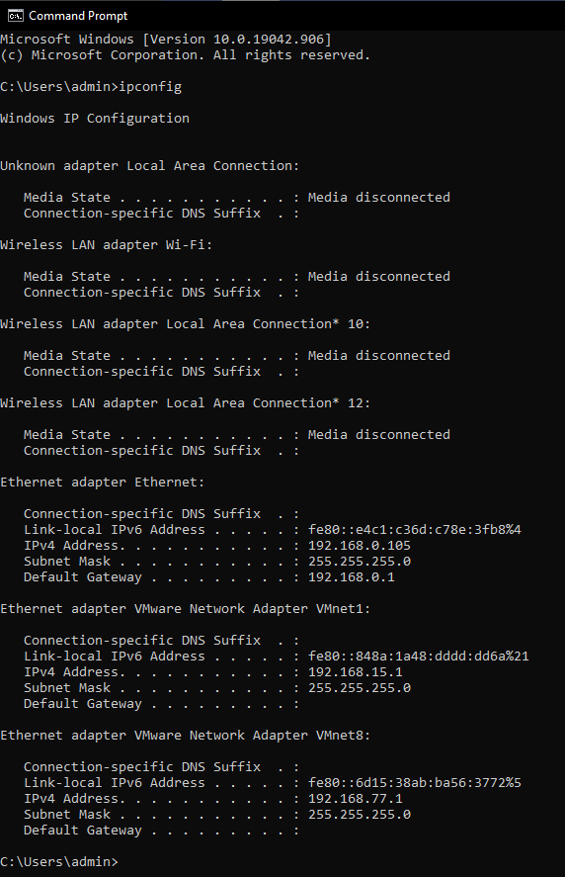

**DOMAIN NAME SERVER.**

For-example https://www.google.com

When a user request it this URL is: A directory (list)of domain names and translate them to Internet Protocol (IP) addresses. This is necessary because, although domain names are easy for people to remember, computers or machines, access websites based on IP addresses.

Scenario1: you don’t want to give access to students particular to some websites but how to do?

Scenario 2: How DNS server exactly works?

DNS SERVER: 

4.Wifi for ipconfig that wifi adapter currently wifi is on so, Here it indicates details of wifi currently XYZ phone is having this ip and ipv4 and subnet mask it is used to get default gateway information in this case xyz is default gateway.

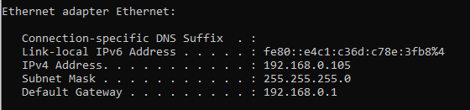

5. ipconfig all: to get all details of ipv4 and ipv6

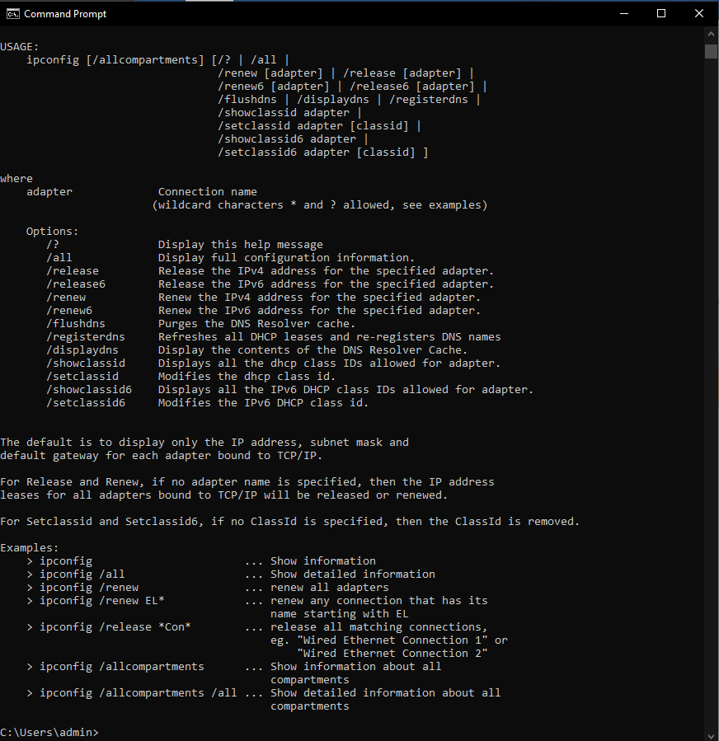

Scenario 3: consider a situation where I want to change or flush my old DHCP ip so for ipv4: release

Ipv6: release6

And then renew

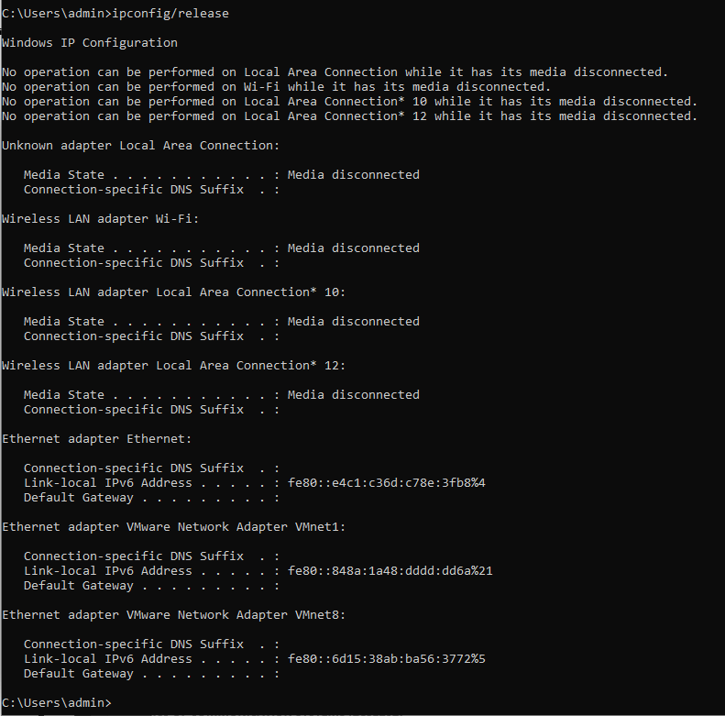

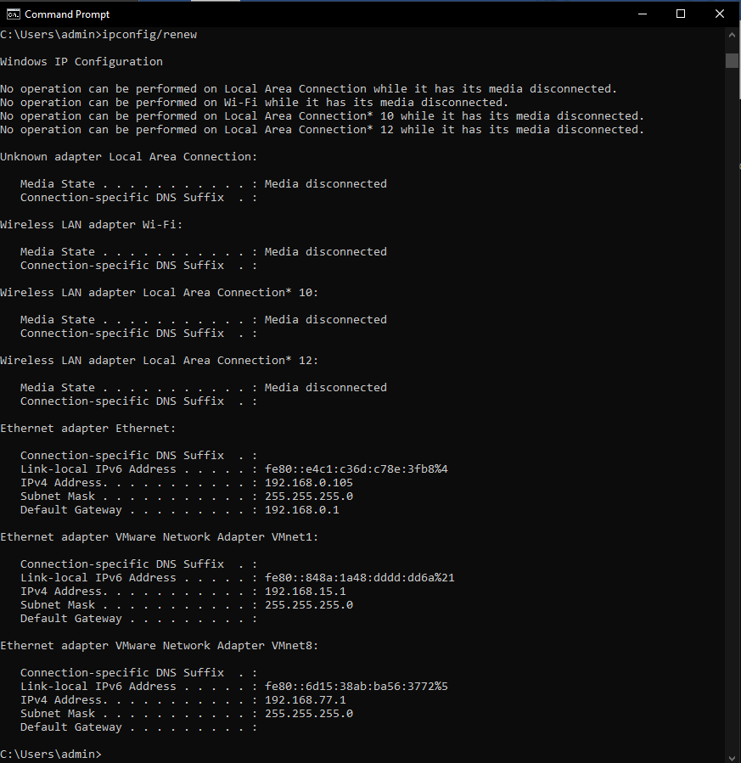

6. Consider a scenario when you want to cross check whether your request is being sent properly or not whether anybody is not accessing your data.

**Ping:**

To check whether I am connected to any website or not? Tracert

For ex: google.com

Ping google.com

Ping 8.8.8.8

Ping 4.4.4.4

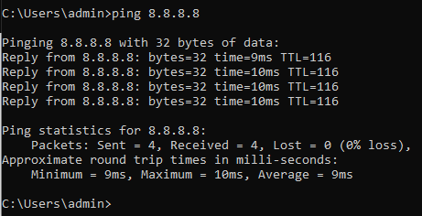

Yes, all packets are sent perfectly to transmitter and I am receiving all

**Tracert command**

for example : a client comes to me that my internet connectivity is not up to the mark how would I find?

Fire this command check the particular route and find out that whether a request is received by server, which route and at which point it has been showing dilemmas or whether switch/router/firewall/ISP/devices. where is the problem occurring?

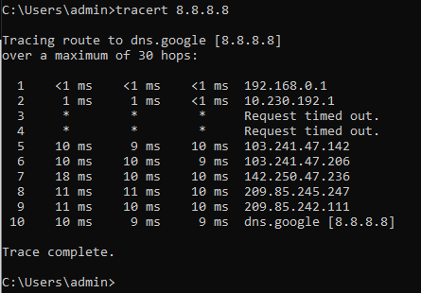

It shows that request is going out from phone (wifi) to switch then lost somewhere and finally to the dns google server

Netstat 8.8.8.8: it is showing that these many active connections are in between to show connections are established there so

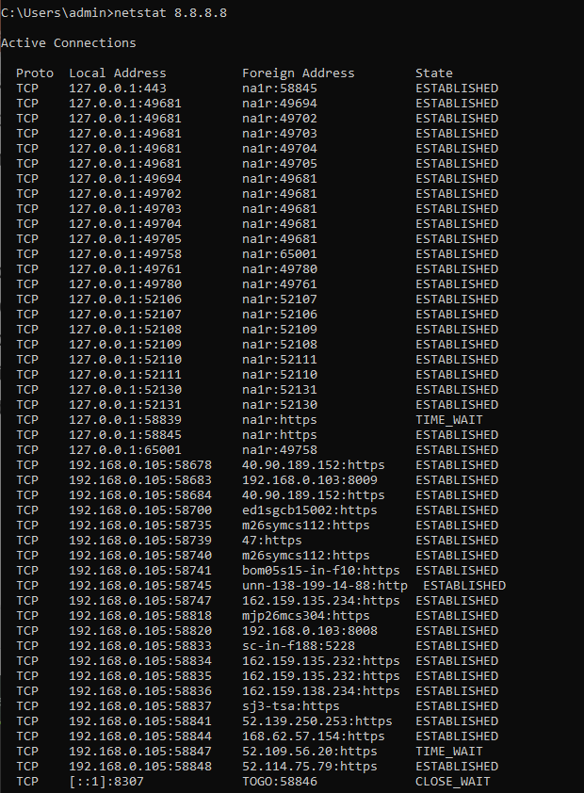

**ARP command**

**ARP** - Address Resolution Protocol

Short for Address Resolution Protocol, a network layer protocol **used to** convert an IP address into a physical address (called a DLC address), such as an Ethernet address. A host wishing to obtain a physical address broadcasts an **ARP** request onto the TCP/IP network.

Consider a situation where ARP address that how many entries has been saved at ARP address

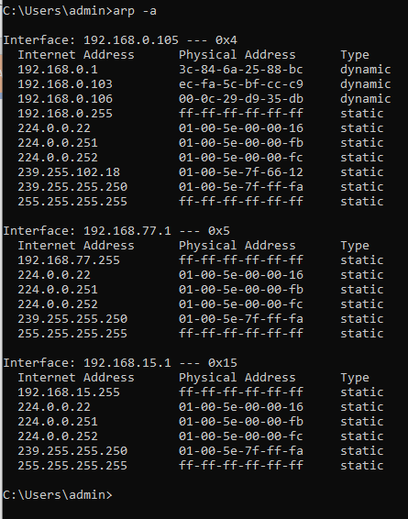

arp -a so these many entries are there save already if I will remove this than it will require more time as no catch memory is stored so it need to map ip address again Looking it we come to know one is dynamic ip address that is of wifi being connected to the device

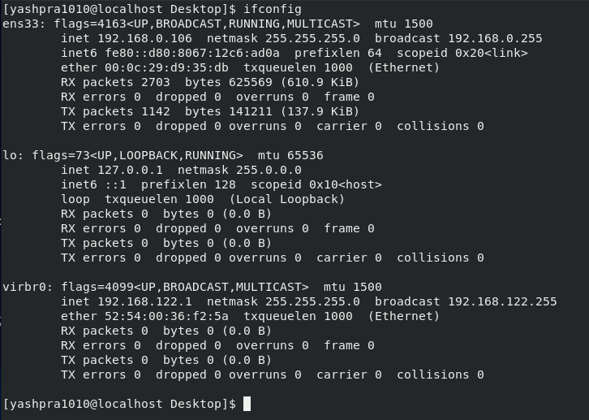

It shows that how many packets are being sent and how many packets are being received:

TX: TRANSMITTED: 1777 bytes

RX: RECEIVED: 1777 bytes Interface configuration:

Consider a situation where your internet connectivity is having problem and you want to see whether all transmitted packets have been received or lost somewhere else.

Whether my ISP is better or on upto which standard so this command will help that how efficient INTERNET SERVICE PROVIDER

**traceroute:**

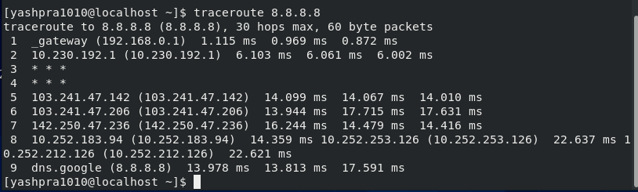

**ss command:**

It is similar to netstat utility used to display **network** connections for the TCP/UDP, **network** protocol statistics, interface statistics, routing tables, masquerade connections, multicast memberships etc. netstat program is obsolete now and its replacement is **ss**.

TCP: consider a situation where we want to acknowledge a connection-oriented request

UDP: without acknowledgement

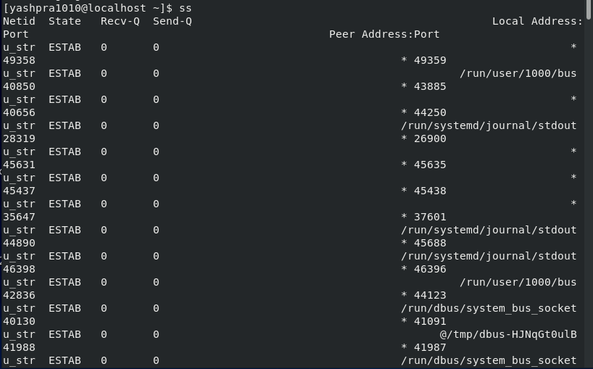

**ss -ta**

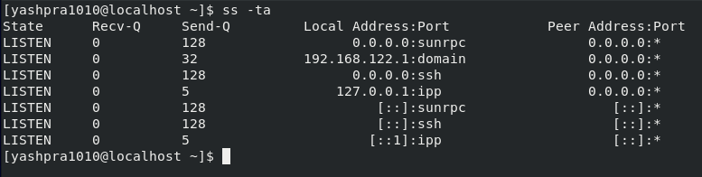

**ss -ua**

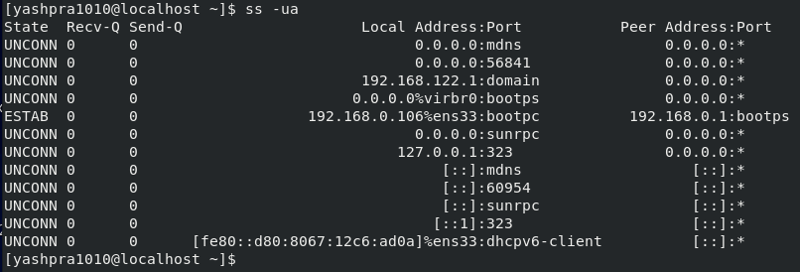

**ss -xa**

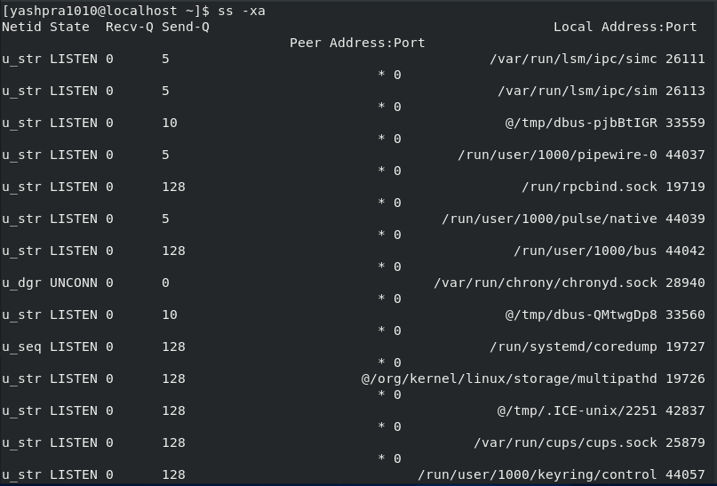

**nslookup:**

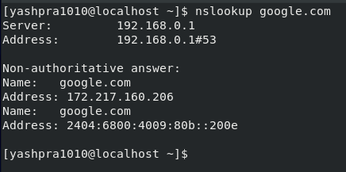

**dig command in linux:**

With the dig command, you can query information about various DNS records,

including host addresses, mail exchanges, and name servers. It is the most

commonly used tool among system administrators for troubleshooting DNS problems because of its flexibility and ease of use.

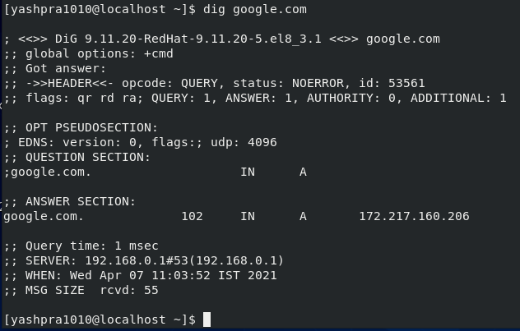

We can also use dig command in another form: dig google and host id:

